CA267 Week 3 - Lab Materials – Instructions:

Testing Requirements

Beech Hill Library Project - Project Aims:

Beech Hill secondary school has 800 students and a teaching staff of 50.

The library is open to the students all day during school hours and is currently operated by the English Department teaching staff on a rotation basis.

Providing an engaging library experience for students with diverse age, skill and competency levels is not easy. In installing a new library system it is envisaged that the students will be able to enjoy an intuitive, friendly and effective interaction with the wealth of information the library has to offer. This software solution must enable the library provide students with a positive and educational library experience.

The new library system will streamline library operations and improve the day-to-day efficiency of the staff. The school also wants to provide students, parents and educators with an affordable, easy-to-use, integrated software solution which will provide for effective management of the library. The solution will support the teachers and learners alike in making the most of the available learning resources - with access to information leading to learning and achievement.

The school require a computer based system that all teachers will be able to use and utilise in helping their students’ access all library items. Records of books, multimedia materials and the like are tracked through the system to determine usage, availability and requests to reserve items.
The main functions of the system are outlined in the diagram below:
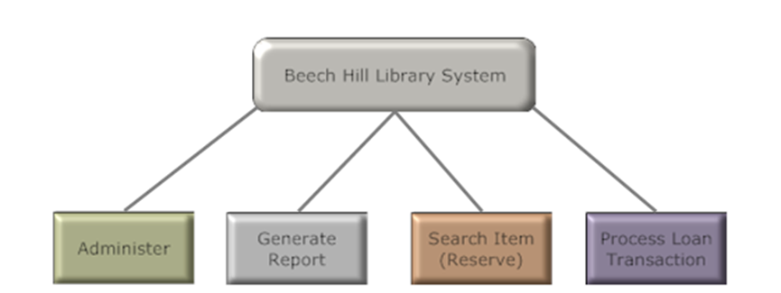
Figure 1- Beech Hill Library System Main Functions

Scenario:
Work in pairs – One of you should take the role of the Business Analyst and one of you should take the role of the Test Analyst. Your team is tasked with simultaneously designing and testing the requirements for the new Beech Hill Library System. Work through the following tasks together.
Note: If the task doesn’t specify the role that should work on the task then you should both work on it and should do so from the perspective of the test analyst.
Task 1.
Neither of you are part of the staff of Beech Hill school but have been tasked with working on the project on behalf of an external company TestABC. This means that you will need to identify the stakeholder on the project.
Make a list of these stakeholders and explain why they will need to be consulted on the project.
Task 2.
Having consulted with the stakeholders that you have identified, list the assumptions, risks and dependencies that you have made regarding the project. Also, explain what is in scope and out of scope for the project.
Task 3.
Using the requirement catalogue provided, identify all requirements associated with the process loan transaction function of the Library System. The Business Analyst should take the lead on identifying the requirements. The Test Analyst should work with the Business Analyst to simultaneously test the requirements – to do this refer to slide 36 in the Week 3 Materials which provides criteria for evaluating the quality of the requirements and apply these criteria when discussing the requirements with the Business Analyst. Record the identified requirements in the requirement catalogue. Consider how critical the requirements are from the business perspective and estimate how technically complex the requirement would be. The Business Analyst should identify both functional and non-functional requirements.
Task 4.
Having identified the requirements in Task 3 above, consider the collective quality of the requirements identified – to do this refer to slide 47 in the Week 3 Materials which provide criteria for evaluating the collective quality of requirements. The Test Analyst should discuss these criteria with the Business Analyst.
Task 5.
As the Test Analyst, you have worked with the Business Analyst to identify the requirements for all the remaining main functions of the Beech Hill Library System and development of the system is underway and the system will be available for test soon. You are aware that there will be bugs in the system. Work with the Business Analyst to develop an approach to finding the bugs in the system. Explain which parts of the system you want to work on and why.
Task 6.
Your boss in TestABC has contacted you to ask how long the testing phase will take for the Beech Hill Project How will you go about estimating how long the test phase will take and what things do you think are the most important to consider? Why is this task difficult to do?
Task 7.
As Test Analyst and Business Analyst you are working together to plan the User Acceptance Testing phase in detail. Work together to identify what exit criteria should apply to this phase of testing. From the exit criteria that you have identified, which could be relaxed if the project goes off course.
Task 8.
For one of the requirements identified in Task 3, write a test case for the requirement. Use the test catalogue provided. What types of defect might you find during the testing phase? How would you decide which defects to fix first? Explain the process that you would use to decide this.

